**Day 8:**

**Syntax for all loops in shell scripting**

**For**

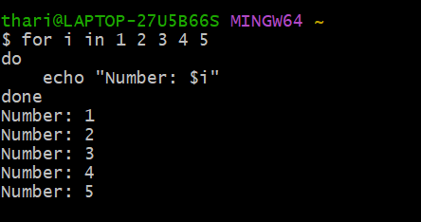

**While Loop**

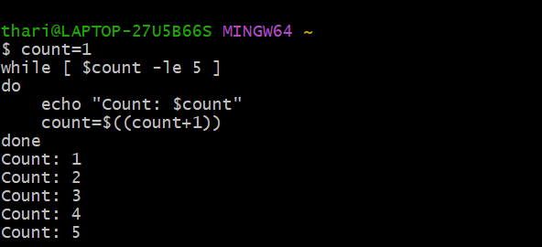

**Until Loop**

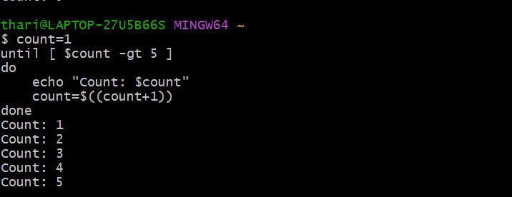

**Select Loop**

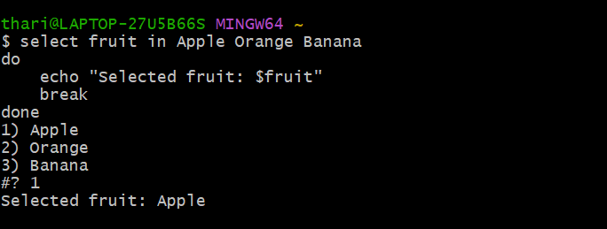

**Day 8 2 SSL Cert Expiry**

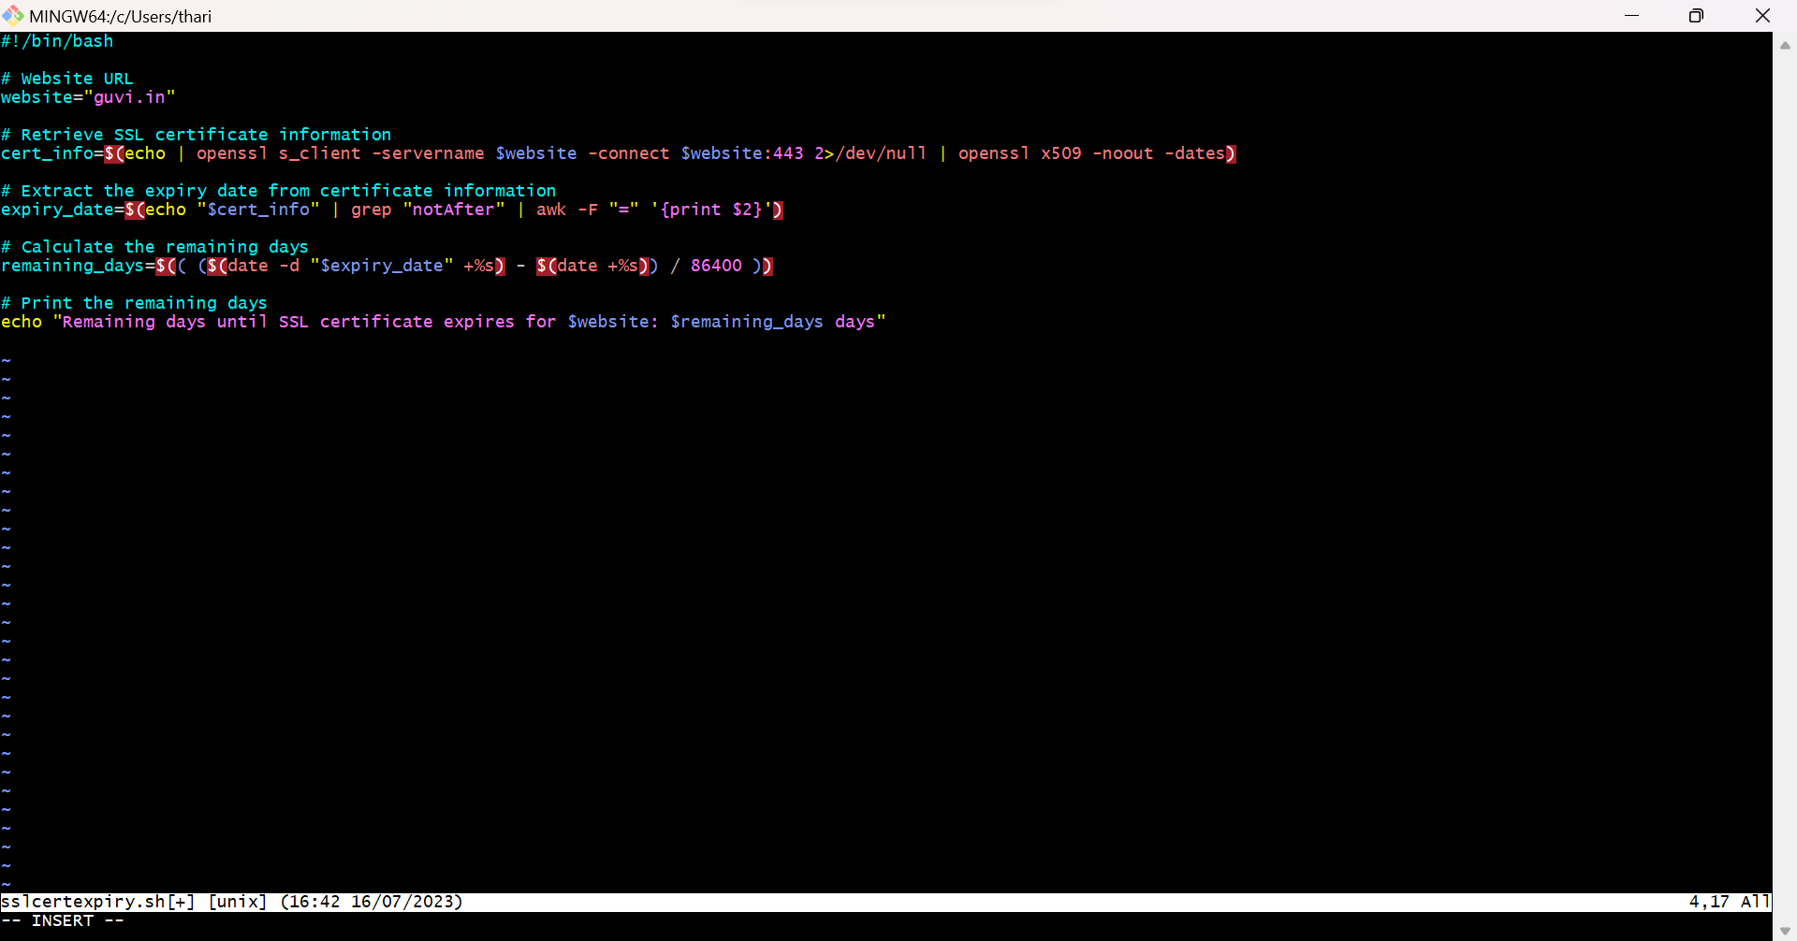

**Balance Days for SSL certs expiry**

